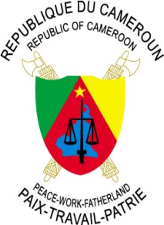
REPUBLIC OF CAMEROON
Peace-Work-Fatherland
---------
EMBASSY IN TURKEY
---------

REPUBLIQUE DU CAMEROUN
Paix-Travail-Patrie
---------
AMBASSADE EN TURQUIE
---------

Nº__________/M/ACT/DC

MESSAGE OF HIS EXCELLENCY THE AMBASSADOR TO WOMEN OF THE CAMEROONIAN COMMUNITY OF TURKEY ON THE OCCASION OF THE 36TH EDITION OF INTERNATIONAL WOMEN'S DAY

08 MARCH 2021

Dear Cameroonian Sisters in Turkey,

Today March 08, 2021, Cameroon joins the rest of the International Community to commemorate the 36th Edition of International Women's Day, celebrated this year under the theme "Women in Leadership: Achieving an equal future in a Covid-19 world”.
On the occasion of this Day dedicated to Women around the world, the entire Staff of the Embassy of Cameroon in Turkey, my spouse and myself, would like to wish you a "HAPPY AND JOYOUS WOMEN'S DAY".
It is equally the venue for me to salute the political agenda of the Government, under the impetus the Head of State, His Excellency Paul BIYA and the immense social projects of the First Lady, Madame Chantal BIYA, in favour of the constant affirmed improvement of the condition of Cameroonian Women.
Despite the international context marked by the spread of the Covid-19 pandemic which prohibits gatherings, we want to wholeheartedly reassure you that, we are with you on this special day.
While renewing to you all, our feelings of encouragement, I would like to seize this happy opportunity to reaffirm the constant availability of the Embassy to work in synergy with you to ensure the maximum fulfilment of Cameroonian women in Turkey.
May the Almighty Lord bless and keep on guiding all of you in your noble roles as Mothers, Wives, Sisters and Daughters by our side.
HAPPY AND JOYFUL WOMEN'S DAY!

